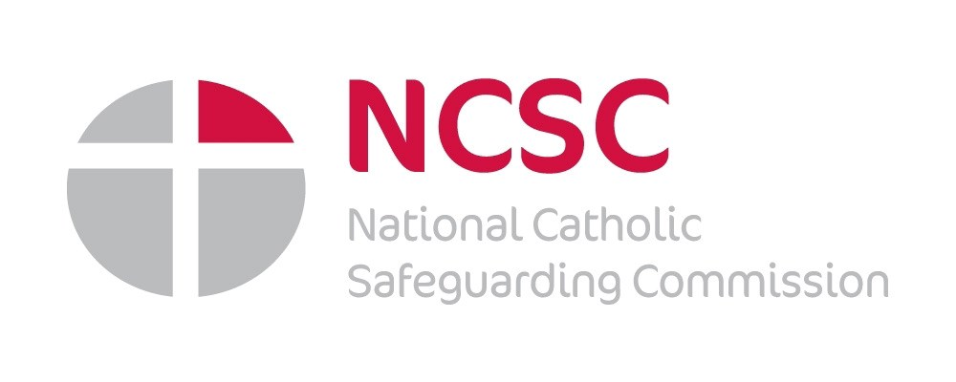
Towards a Culture of Safeguarding.
The Church has a responsibility to ensure all those who undertake work in the name of the Church are adequately trained in safeguarding matters.
The Catholic Church is dependent on Clergy, Religious and Lay people using their skills and
talents to nurture and support the Catholic community. Some will be paid employees, but the
majority undertake their work on a voluntary basis. Whilst some will recognise their role as a volunteer, many rightly see their caring and support contribution as part of their Christian responsibility and ministry.
But we all have a role to play in safeguarding the young or adults who may be at risk and it is for this reason that we have worked with EduCare to bring you an e-learning package that will raise
awareness throughout the Catholic Community in England and Wales. The e-learning package is part of the Church’s commitment to safeguarding, and is available to all members of the Catholic community free of charge.

National Catholic Safeguarding Commission
We have not always been alert to concerns, we have not always responded as we should, but we are listening, learning, changing.
“The Catholic Church in England and Wales is striving towards a
culture of safeguarding where all are safe from harm and abuse and where every person is encouraged and enabled to enjoy the fullness of life in Jesus Christ through the prayerful, caring, nurturing, supportive and protective endeavours of the Catholic community, both individually and collectively.” TaCoS 2012
The following programmes are available.

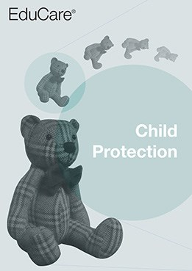
Child Protection
Covers the fundamentals of safeguarding and protection for anyone who comes into contact with children and young people through their work or voluntary activities. The programme is delivered in a simple and engaging way.

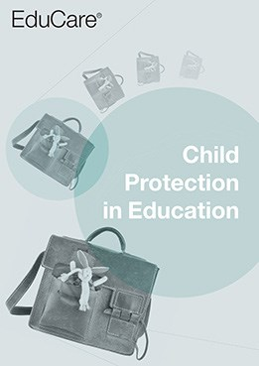
Child Protection in Education
Child Protection in Education is designed for those who work with children and young people in an education setting. Its purpose is to raise your awareness of abuse and neglect, help you to recognise early signs that might indicate a problem, and show you how to take appropriate action.

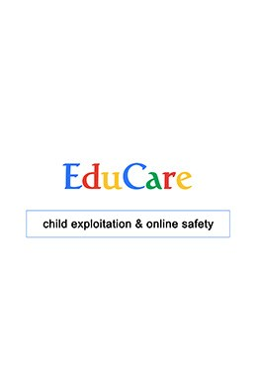
Child Exploitation & Online Safety
Written by Jonathan Taylor, a leading expert in e-safety and protecting children online, the training aims to bring you up-to date on how children and young people use technology and the associated risks. It also provides the essential information to help protect children and young people from sexual exploitation.

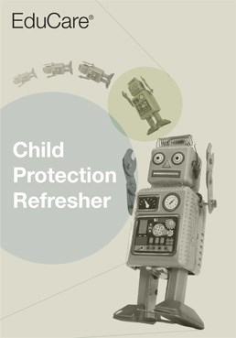
Child Protection Refresher
Child Protection Refresher is designed for those who have already undergone level 1 or 2 child protection training who wish to refresh their knowledge, keep up to date with recent changes in legislation and guidance, and stay aware of recent serious case reviews.
Visit educare.co.uk to find out more about each programme.

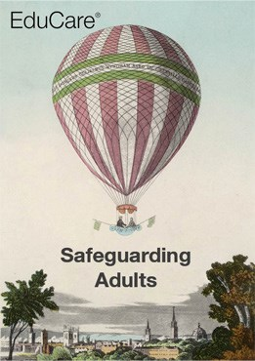
Safeguarding Adults
Safeguarding Adults provides the key information needed to help safeguard adults at risk. The four concise learning modules cover the basics of abuse, how to recognise situations where abuse might occur, the signs of abuse, the importance of taking action, and good practice guidelines.

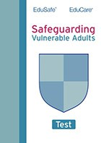
Safeguarding Adults Refresher
Safeguarding Adults Refresher is designed for people who have already completed training on the subject (such as the Safeguarding Adults programme). This questionnaire will test knowledge in relation to safeguarding vulnerable adults and is suitable for anyone who comes into contact with them during work or voluntary activities.

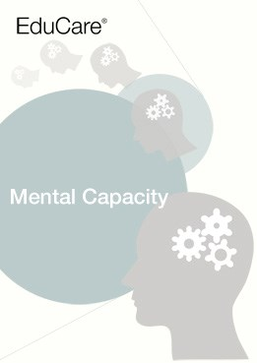
Mental Capacity
This training introduces the fundamentals of the Mental Capacity Act (MCA) 2005 (which came into full force in 2007) and the Deprivation of Liberty Safeguards (DoLS).

Each programme is meticulously considered to be at the service of the learner.
Video and imagery Engaging interactivity Responsive design Voiceover and audio

The Catholic Trust of England and Wales has purchased a package of e-learning programmes that are available to every member of the Catholic community in England and Wales.
How can we ensure that everyone working with the young have a basic awareness of safeguarding matters?
By providing an opportunity for individuals to access online training on a variety of topics at a time and place that suits them. EduCare’s training programmes can help individuals
familiarise themselves with safeguarding matters, helping to create a nurturing and safer environment. The Child Exploitation & Online Safety programme will be of particular interest to parents who will be keen to understand how children and young people use technology and better understand the associated risks.
How many programmes can learners complete?
Every member of the Catholic community in England and Wales can access every programme and complete as many as they choose.
How are the programmes made up?
Each programme is modular, and divided up into a bite-sized format. You will need internet access to launch a programme and save your progress.
What do I need to do to access this training resource?
- Email johannapeluso@dioceseofbrentwood.org to register your interest.
- Your email should contain your name, email address, the name of your parish/order/congregation, and your role. For example: Priest, Member of the Religious, Safeguarding
Representative, Youth Worker, Teacher, SVP or Other Volunteers, Parent/Grandparent/ Guardian, or Other.
- On receipt of your email the safeguarding administrator will register your email address with EduCare.
- You will receive a Welcome Email from EduCare where you will set your password.
- You will then have instant access to the training programmes.

