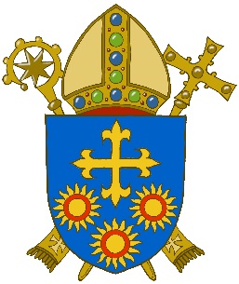
WHAT DO YOU THINK ABOUT YOUR SCHOOL?
Please use this paper to tell us what you think about your school.
Do not put your name on it.
Year Group:

Draw a ring around your answer to each question, like this: Sometimes

1 | Do you like being at this school? | Yes | Mostly | Sometimes | No
2 | Do other children behave well? | Yes | Mostly | Sometimes | No
3 | Do you find out new things in Religious Education lessons? | Yes | Mostly | Sometimes | No
4 | Are your Religious Education lessons interesting and fun? | Yes | Mostly | Sometimes | No
5 | Do you get help when you are stuck? | Yes | Mostly | Sometimes | No
6 | Do you have to work hard? | Yes | Mostly | Sometimes | No
7 | Do teachers show you how to make your work better? | Yes | Mostly | Sometimes | No
8 | Are teachers fair to you? | Yes |  |  | No
9 | Do teachers listen to your ideas? | Yes | Mostly | Sometimes | No
10 | Are you trusted to work independently? | Yes | Mostly | Sometimes | No
11 | Do you enjoy your times of prayer together? | Yes | Mostly | Sometimes | No

Do you want to say anything else about your school? Please write in the box, but do not write down the names of teachers or other adults.
What I like most about my Religious Education lessons

What I would like to change about these lessons

