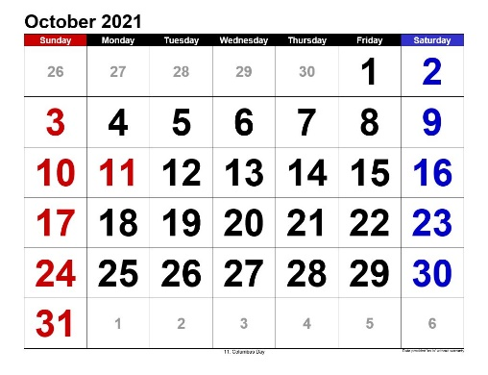SAVE THE DATE!

ESSEX CLERKS’ ASSOCIATION

CONFERENCE IS BACK

TUESDAY 19 OCTOBER

We look forward to welcoming you all

to the JobServe Community Stadium

(Colchester United Football Club)

9am – 1.30pm

Lunch available

Keynote Speaker: Pam Langmead

3 Informative Workshops

Free Lunch available

If you would like to register your interest please email: [bookings@essexclerks.org](mailto:secretary@essexclerksassociation.co.uk)