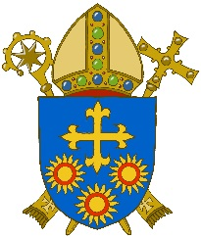
D I O C E S E O F B R E N T W O O D
Diocesan Safeguarding Advisory Panel

PARISH OF………………………………………………….

Role: Bereavement Home Visitor

Responsible to: (The Parish Priest, his Delegate or leader for that group)

Main Responsibilities:

- To undertake specified training as directed by the Parish Priest to help in their role as a Bereavement Home Visitor.
- To attend regular support meetings as arranged by the Parish Priest or Facilitator.
- To ensure that good practice and ethical guidelines are being maintained as outlined in the training.
- To provide one to one support to the bereaved, at their request, at least six to eight weeks following their loss.
- To agree that notes will be kept separate and in a secure place to ensure confidentiality.

Person Specification:

- A good listener with good communication skills
- Non-judgemental
- Ability to set clear boundaries with an awareness of the importance of confidentiality.
- The ability to be with others, experiencing their feelings of loss without being overwhelmed.
- The ability to listen without the need to explore or discuss, in detail, their own loss/es.

Guideline

If the prospective Bereavement Home Visitor has had a recent bereavement, it will be at the discretion of the Parish Priest or Facilitator to determine the time allowed before becoming a Bereavement Home Visitor.

Registered Charity No. 234092 – Website: www.dioceseofbrentwood.net March 2023

