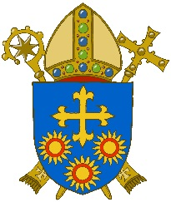
D I O C E S E O F B R E N T W O O D
Diocesan Safeguarding Advisory Panel

PARISH OF _______________________________________

Role: Folk Group – responsible adult

Responsible to: Parish Priest

Age range: 8 – adult

Aim: To provide a point of contact within the Folk Group, who will ensure that
Safeguarding procedures are adhered to and will raise any concerns with the appropriate person.

The appropriate person will normally be either the Parish Safeguarding
Representative or the Parish Priest.

Main Responsibilities:

- To work with the Parish Priest, other members of the Folk Group (both adults and children) and the wider parish community in incorporating music into the liturgies.
- To support the development of the faith of young people with whom they are working.
- To provide a safe and supportive environment in which young people can freely share their experiences, opinions and questions.
- To maintain appropriate boundaries.
- To ensure that rehearsals, practice sessions and participation in the liturgy are conducted in accordance with Diocesan Safeguarding Procedures.

Person Specification:

- Commitment to the teachings of the Catholic Church and the development of the parish community.
- Ability to relate with respect and ease to young people and to communicate clearly.
- Willingness to share your own faith experience with others and be open to challenge and grow in your own faith.
- All volunteers should be over 18 years of age.

Protection of Children and Adults at Risk:

- To familiarise themselves with National Safeguarding Policies.
- To refer any concerns about a child or adult at risk to the Safeguarding Representative in the Parish.
- To be willing to participate in basic safeguarding training.

Registered Charity No. 234092 – Website: www.dioceseofbrentwood.net March 2023

