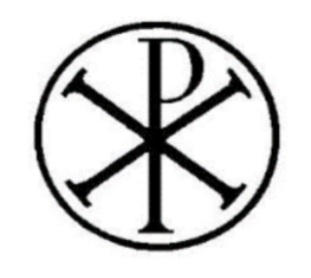  Catholic Biblical Association (GB) | 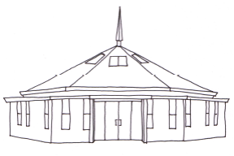 | 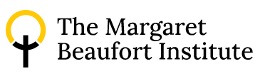

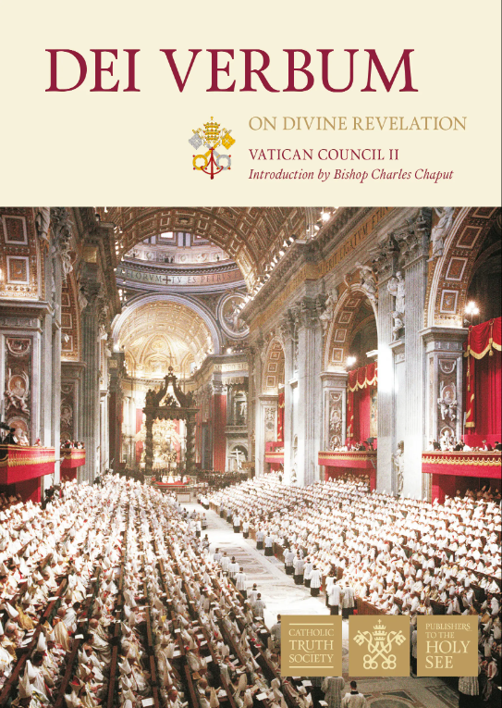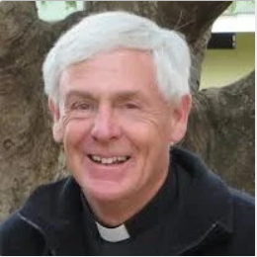

Dei Verbum, 60 Years On

Fr Nicholas King SJ will share his own personal insights - as a biblical scholar and translator - on the Second Vatican Council document on divine revelation, Dei Verbum (Pope Paul VI, 18 November 1965).
How does the document come across today? Can it help us to read, study and pray the Scriptures in our time?

Saturday 22nd November 2025
11.00 – 14.00 GMT

The speaker will be present in-person, but this free event is also live-streamed on www.whatgoodnews.org If you are attending in person please email gideapark@brcdt.org or sign-up using Eventbrite on the Margaret Beaufort Institute website https://www.mbit.cam.ac.uk/

Christ the Eternal High Priest Catholic Church, Gidea Park RM2 6DH

Coffee available 10.30. Please bring a packed lunch. Venue is five-minutes’ walk from Gidea Park station (Elizabeth Line). Parking available and local eateries. Recording free to view on website later.

