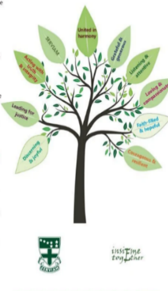

URSULINE EDUCATION COMMUNITY

The Ursuline sisters wish to appoint an Ursuline Education Community Director for their schools’ programme. The ideal candidate will have previous experience of working in a school or parish setting to motivate and inspire young people. This role will involve working with students and staff in the six Ursuline schools and the Ursuline Links Director.

The key responsibility of the UEC Director will be to ensure that the Ursuline Mission and Identity is kept vibrant and alive in the school community.

Working Hours - 37.5 hours per week (part-time considered)
Location – Home based with travel to the schools and other Ursuline meetings
Contract - Permanent
Salary - £45,000 - £50,000 per annum (full time equivalent)
Annual Leave - 33 days holiday (pro rata) per year inclusive of bank holidays.

MAIN RESPONSIBILITIES:
- Alongside the Ursuline Delegate and UEC Trustees, agree the strategic direction of the Ursuline schools’ implementation of the Virtues’ programme ensuring close alignment with the charity’s goals and objectives.

- Develop a full understanding of Ursuline Links Programme so that it and the UEC Virtues’ Programme can work in tandem to develop the Ursuline ethos within students from their first day in Yr 7.

- Strategically review existing Virtues’ initiatives with a focus on their further development and support their implementation across the schools.

- Ensure that the Virtues’ programme gives the students a solid foundation in their understanding of human virtues that will enrich their experience of school and help them become reflective, discerning and generous young adults.

- Ensure the virtues programme remains relevant for students and staff from a variety of faith and non-faith backgrounds.

HOW TO APPLY:
If you feel you have the relevant skills and experience to fulfil this role successfully, please apply in the first instance with your CV to Sr. Kathleen Colmer provincial.ursuline@gmail.com.

All suitable candidates will receive the full job description and an application form to complete.

Closing Date for completed applications: 8th October 2026

