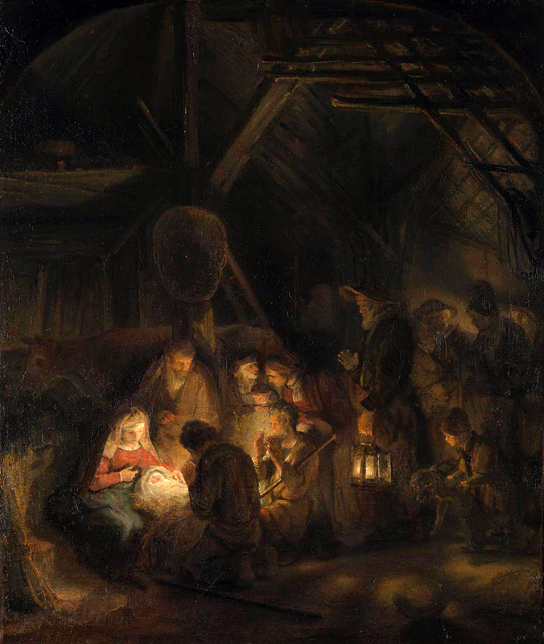

Moderation Record
Year 1, Branch 3 - Galilee to Jerusalem
School (including location): ____________________________________
Pupil’s Full Name: ____________________________________
Pupil’s Class: ____________________________________
Name of Subject Leader: ____________________________________
Schools in Moderation Group: ____________________________________
____________________________________
Original Assessment: Meeting / Not Meeting
Moderated Assessment: Meeting / Not Meeting
Diocesan Moderator: ____________________________________
Date: ____________________________________

U1.3.1 - Identify some of the people that encounter Jesus and recognise that he is special.

Knowledge Lens: Hear / Subject Area: Revelation

1. Skills and Content
☐ | The Pupil shows the appropriate knowledge and skills for this outcome
 | What is this really about? Gospel encounters introduce pupils to the Christian belief that God makes himself known through Jesus.
Driver Word/s: Identify, recognise.
Driver Meaning at this Age-Phase: At Ages 5-7, identify means recognising people by given names or roles; recognise means beginning to make simple connections between sources and beliefs. Initial recognition may be supported, without requiring full mastery of broader skills or complete retelling.

2. Misconceptions
☐ | No significant misconceptions are present in the pupil's work.

Examples
Examples of 'Meeting' | Examples of 'Not Meeting'
- Identifies some people from the encounters taught, using names or accurate roles such as ‘the children’ and ‘the disciples’. Names are not needed where the passage does not give them.  - Recognises something Jesus says or does in the account and makes a simple, possibly supported connection with Christian belief that he is God’s Son and makes God’s love known.  - Shows this through speech, labelled drawing, picture choices or pointing with brief clarification. A full written explanation is unnecessary.  Key pupil language includes Jesus, God and God’s Son or Son of God, alongside relevant character names or roles. ‘Revelation’ and ‘definitive revelation of God’ are teacher-facing theological language, not required pupil vocabulary. | - Names biblical people without identifying whether they appear in the encounter being assessed.  - Treats Jesus’ actions as magic or assumes that everyone who met him immediately understood who he was.  - Offers only a personal response, such as ‘I like Jesus’, or a moral message, such as ‘Be kind’, without showing understanding of the encounter and Jesus’ identity.  - Copies a supplied sentence without showing its meaning through another response, choice or indication.

Factors Affecting Judgement
Use professional judgement to decide whether any of the following factors make it hard to tell if the evidence is valid.

3. Salience
☐ | Skills or content are not displaced by irrelevant, excessive, or misdirected material or tasks.
 | Jesus is special because he is God’s Son, whose words and actions reveal God to people. Learning should not stop at naming Bible characters, admiring impressive deeds or drawing a general lesson about kindness.

4. Independence
☐ | No evidence of excessive adult support such as excessive use of copying, model answers, sentence stems, fill-in-the-blank (cloze).

5. Irrelevant Factors
☐ | Judgement is not affected by irrelevant features such as handwriting, presentation, quantity of writing etc.

Overall Judgement
☐ Unclear | ☐ Not Meeting | ☐ Meeting

U1.3.2 - Retell, in any form, one of the stories they have heard, recognising these are religious accounts from the Gospel of Luke.

Knowledge Lens: Hear / Subject Area: Sacred Scripture
(This outcome is linked to more than one Knowledge Lens or Subject Area – For this outcome, this is moderation sheet 1 of 2)

1. Skills and Content
☐ | The Pupil shows the appropriate knowledge and skills for this outcome
 | What is this really about? Pupils begin to know Jesus through a familiar account from Luke’s Gospel.
Driver Word/s: Retell, recognising.
Driver Meaning at this Age-Phase: At Ages 5–7, retelling means communicating a narrative in any form, preserving its main people, events and meaning faithfully to the source. Recognising means beginning to recognise literary forms and acknowledge the source. Familiar images and prompts can support these developing skills.

2. Misconceptions
☐ | No significant misconceptions are present in the pupil's work.

Examples
Examples of 'Meeting' | Examples of 'Not Meeting'
- A connected retelling communicates the main people, events and ending of the passage heard. Familiar pictures or simple prompts may support this; exact reproduction of the wording is unnecessary.  - Pupils name or identify the Gospel of Luke and recognise the account as belonging to the Bible, through which Christians come to know Jesus. Recognition may be communicated through speech, pointing or communication aids.  - The retelling retains the account’s religious focus, including Jesus’ place in it. Where relevant, wording such as ‘Jesus told them a story…’ can show beginning recognition of the difference between a story Jesus tells and an account of his actions.  Vocabulary: ‘Gospel of Luke’ is the key source name; ‘Bible’ supports recognition. Formal explanations of inspiration, canonical Scripture or apostolic testimony are teacher-facing theological background, not pupil requirements. | - Naming characters or selecting one correct picture without conveying the account.  - Repeating ‘Luke’ immediately after an adult without showing source recognition in a fresh check.  - Giving only a general message such as ‘be kind’, or producing a retelling that materially changes the main actions or ending, or combines separate Gospel accounts.

Factors Affecting Judgement
Use professional judgement to decide whether any of the following factors make it hard to tell if the evidence is valid.

3. Salience
☐ | Skills or content are not displaced by irrelevant, excessive, or misdirected material or tasks.
 | The account belongs to Sacred Scripture, through which Christians believe God makes himself known in Jesus. Avoid changing the account into an invented story or reducing its meaning to a rule such as “be kind”.

4. Independence
☐ | No evidence of excessive adult support such as excessive use of copying, model answers, sentence stems, fill-in-the-blank (cloze).

5. Irrelevant Factors
☐ | Judgement is not affected by irrelevant features such as handwriting, presentation, quantity of writing etc.

Overall Judgement
☐ Unclear | ☐ Not Meeting | ☐ Meeting

U1.3.2 - Retell, in any form, one of the stories they have heard, recognising these are religious accounts from the Gospel of Luke.

Knowledge Lens: Hear / Subject Area: The Good News of Redemption
(This outcome is linked to more than one Knowledge Lens or Subject Area – For this outcome, this is moderation sheet 2 of 2)

1. Skills and Content
☐ | The Pupil shows the appropriate knowledge and skills for this outcome
 | What is this really about? Pupils begin to recognise Luke’s Gospel as Scripture through which Christians come to know Jesus and God’s saving work.
Driver Word/s: Retell, recognising.
Driver Meaning at this Age-Phase: At Ages 5–7, retelling means communicating a heard narrative faithfully, preserving its main people and actions through speech, drawings or acting. Recognising means beginning to identify its character and source. Support is appropriate; independent writing and mastery of the whole phase’s expectations are not required.

2. Misconceptions
☐ | No significant misconceptions are present in the pupil's work.

Examples
Examples of 'Meeting' | Examples of 'Not Meeting'
- A recognisable retelling of one heard account, through speech, drawing, supported communication or acting. Main people and actions remain faithful to the passage, with enough sequence to communicate what happens.  - Recognition that the account belongs to Luke’s Gospel in the Bible, shown through simple words or a meaningful selection from familiar source materials.  - Attention to the account’s religious character: the retelling preserves important words or actions concerning Jesus or God. A simple comment such as ‘Christians hear this account to learn about Jesus’, alongside the retelling, may also show recognition. A separate theological explanation is unnecessary.  Relevant pupil vocabulary is Jesus, Bible, Gospel and Luke, used or recognised in context. ‘Revelation’, ‘redemption’ and ‘apostolic witness’ are teacher-facing framing, not required pupil terminology. | - Naming Luke, copying a caption or repeating an adult’s answer without demonstrating recognition in context.  - Arranging pictures correctly without communicating the account through words, actions or another accessible form.  - Offering only an attractive detail, a general rule such as ‘be kind’, or an invented ending that changes the account’s meaning.  Record the support given. Artistic quality, fluent speech and confident performance are not evidence of stronger religious understanding.

Factors Affecting Judgement
Use professional judgement to decide whether any of the following factors make it hard to tell if the evidence is valid.

3. Salience
☐ | Skills or content are not displaced by irrelevant, excessive, or misdirected material or tasks.
 | The account’s meaning about Jesus must remain central within its particular people, words and events. Avoid turning the account into an invented adventure or reducing its meaning to a rule such as “be kind”.

4. Independence
☐ | No evidence of excessive adult support such as excessive use of copying, model answers, sentence stems, fill-in-the-blank (cloze).

5. Irrelevant Factors
☐ | Judgement is not affected by irrelevant features such as handwriting, presentation, quantity of writing etc.

Overall Judgement
☐ Unclear | ☐ Not Meeting | ☐ Meeting

U1.3.3 - Make simple connections between Jesus’ announcement of his mission (Lk 4:16-19) and how Christians are called to tell people about God’s love today.

Knowledge Lens: Live / Subject Area: Faith and life

1. Skills and Content
☐ | The Pupil shows the appropriate knowledge and skills for this outcome
 | What is this really about? This outcome connects Jesus’ mission with how Christians share God’s love in everyday life.
Driver Word/s: Make simple connections.
Driver Meaning at this Age-Phase: At Ages 5-7, this means recognising simple links, with support through talk or pictures. A developed explanation is not required.

2. Misconceptions
☐ | No significant misconceptions are present in the pupil's work.

Examples
Examples of 'Meeting' | Examples of 'Not Meeting'
- Through speech, drawing with explanation, or an adult-scribed response, the pupil makes a simple connection between Jesus’ announcement and Christians sharing God’s love today.  - An indicative response is: ‘Jesus brought good news to poor people. Christians tell people God loves them and help people who need food.’ Equivalent child-friendly wording is sufficient.  - The response connects caring actions with the Christian message about God’s love, rather than describing kindness alone. One clear example is sufficient.  - Pupils use or recognise Jesus, Christians, God’s love and good news meaningfully. Teacher-facing terms such as evangelisation, proclamation and saving mission are not required pupil vocabulary. | - Naming Jesus, copying ‘Good News’ or retelling the synagogue scene without a connection to Christian life today.  - Saying only ‘Be kind’, producing an attractive postcard, or matching pictures without indicating what connects them.  - Suggesting that Christians must make other people believe, or that Christians themselves can guarantee healing or remove every difficulty.  - Expressing personal faith or promising to help someone; these do not by themselves demonstrate the assessed understanding.

Factors Affecting Judgement
Use professional judgement to decide whether any of the following factors make it hard to tell if the evidence is valid.

3. Salience
☐ | Skills or content are not displaced by irrelevant, excessive, or misdirected material or tasks.
 | Christians’ words and care for others flow from faith in Jesus, who reveals God’s love. Avoid reducing the outcome to general kindness, speaking alone, or pressuring others to become Christians.

4. Independence
☐ | No evidence of excessive adult support such as excessive use of copying, model answers, sentence stems, fill-in-the-blank (cloze).

5. Irrelevant Factors
☐ | Judgement is not affected by irrelevant features such as handwriting, presentation, quantity of writing etc.

Overall Judgement
☐ Unclear | ☐ Not Meeting | ☐ Meeting

